Ideation Phase
Define the Problem Statements

Date | 15 July 2026
Team ID
Project Name | House Rent
Maximum Marks | 2 Marks

Customer Problem Statement Template:
Create a problem statement to understand your customer's point of view. The Customer Problem Statement template helps you focus on what matters to create experiences people will love.
A well-articulated customer problem statement allows you and your team to find the ideal solution for the challenges your customers face. Throughout the process, you’ll also be able to empathize with your customers, which helps you better understand how they perceive your product or service.

Reference: https://miro.com/templates/customer-problem-statement/
Example:


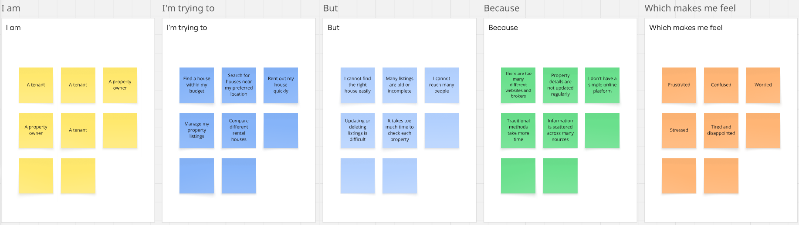

Problem Statement (PS) | I am (Customer) | I’m trying to | But | Because | Which makes me feel
PS-1 | A tenant | Find a house within my budget | I cannot find the right house easily | There are too many different websites and brokers | Frustrated
PS-2 | A tenant | Search for houses near my preferred location | Many listings are old or incomplete | Property details are not updated regularly | Confused
PS-3 | A property owner | Rent out my house quickly | I cannot reach many people | I don't have a simple online platform | Worried
PS-4 | A property owner | Manage my property listings | Updating or deleting listings is difficult | I don't have a simple online platform | Worried
PS-5 | A tenant | Compare different rental houses | It takes too much time to check each property | Information is scattered across many sources | Tired and disappointed

